**Chitt Chongmankhong (1922-2009)**

Chitt Chongmankhong was one of Thailand’s foremost artistic photographers, and is today referred to as ‘the father of Thai photography.’ Chitt is recognised for his innovative use of darkroom techniques, and would often say that 30 percent of photographic accomplishment is in taking the photograph and 70 percent is from expertise in the darkroom. In addition to owning his own commercial photographic store, from 1958 Chitt was also a member of the Royal Thai Photographic Society (RTPS) and served as the organisation’s president from 1987-8. He frequently travelled outside Bangkok to take photographs of the Thai landscape and portraits of ordinary people, sometimes with other members of the RTPS. His photographic compositions were generally carefully planned, sometimes adopting a Pictorialist style in their atmospheric rendering of light and shadow and in their representation of different weather conditions and landscapes. However, Chitt’s constant fascination with darkroom techniques meant that his work also sometimes took the form of Surrealistic collages or interrogations into the photographic medium itself. While in his early career his style was unpopular within Thailand’s photographic community, his receipt of many international awards eventually legitimised his work locally. Chitt became a National Artist of Thailand in 1995.

The son of poor Cantonese migrants, Chitt began his career as a radio repairman in a famous photography store on Siphraya road in Bangkok. There he gained access to the darkroom and learned darkroom techniques from his colleagues. Apart from this Chitt was largely a self-taught photographer, and utilised English and Chinese language magazines and books to develop his skills at a time when no Thai language manuals existed. He also developed his compositional style from viewing American films, and this influence can be seen in some of the cinematic, highly stylised and dramatic compositions of some of his photographs including *Drunk* (1960) and *When Love Ends* (1986). By the end of 1945, Chit had begun work at the Osathakarn department store in the photography department before opening his own photography store with his brother. By the 1960s, he opened his own photographic studio and developing lab where he also undertook a limited number of advertising photography assignments including one for Volkswagen in Thailand.

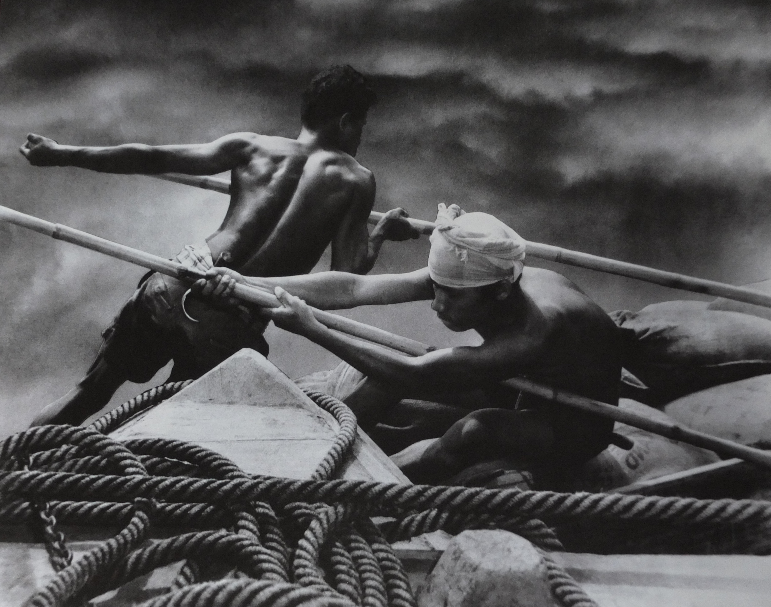

Chitt Chongmankhong, *When the Storm Comes*, 1960, silver gelatin composite print, Chongmankhong Family Collection.

*When the Storm Comes* (1960) is Chitt’s best-known photograph and demonstrates his innovative use of darkroom techniques. The final print was a composite of two images: men working on a boat and a stormy sky, and was created utilising techniques of photomontage, which he named ‘paste photography for art.’ The photograph was poorly received in Thailand but soon won prizes at international photography exhibitions including, Photographic Society of Hong Kong (1963), Society of Photographic Art, Denmark (1964), International Exhibition of Photography, Rijeka, Yugoslavia (1966), Interpressfoto, Moscow (1966) and International Photographic Exhibition, People’s Republic of China (1981). The work was then presented to King Bhumibol Aduladej in 1975 and its quality was thus legitimised in Thailand.

**References and Further Reading**

Chit Chongmankhong (1998) *A Compendium of Five Decades of Monochrome Photography Seen Through the Camera Lens and in a Darkroom by Chitt Chongmankhong, National Artist of Thailand*, Bangkok: Image Publishing Co. Ltd. (In Thai and English)

Uab Sanasen (1986) *Phap Thay Khong Chitt Chongmankhong (The Photography of Chitt Chongmankhong*)*,* Bangkok: Borisat Dan Sutthakanphim. (In Thai)

Zhuang Wubin (2012) ‘Post-Second World War Photography in Southeast Asia,’ in *Asian Art Newspaper*, (<http://www.asianartnewspaper.com/article/post-second-world-war-photography-southeast-asia>)